

UNIVERSITY OF PETROLEUM AND ENERGY STUDIES
DEHRADUN

CYBER THREAT INTELLIGENCE

LAB 8

Learn Advanced OSINT Investigations

MTECH-COMPUTER SCIENCE
ENGINEERING
CYBER SECURITY AND FORENSICS

Name: Jigesh Sheoran
SAP ID: 590025428

Objective — Learn to discover the world around you

Investigation 1
For investigating 1 this image has been provided.
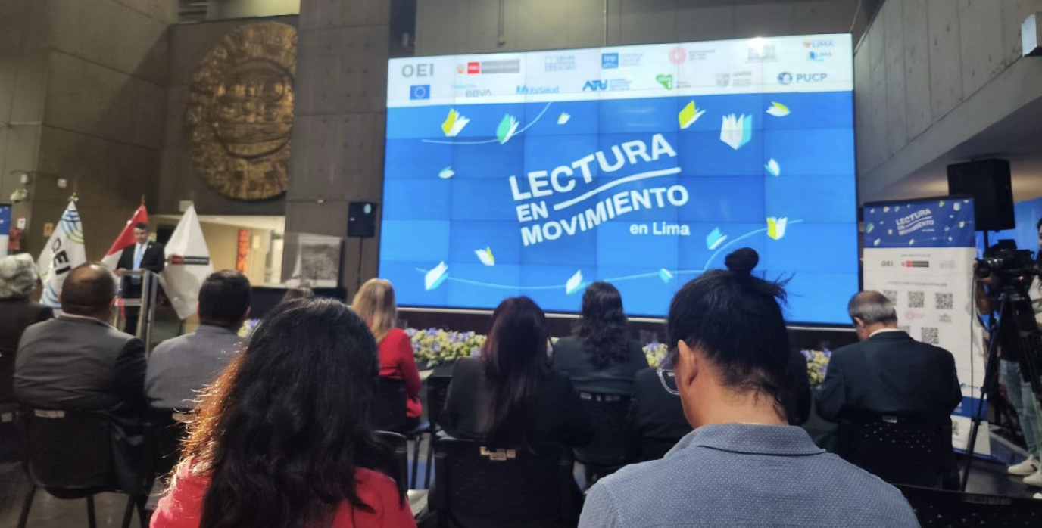
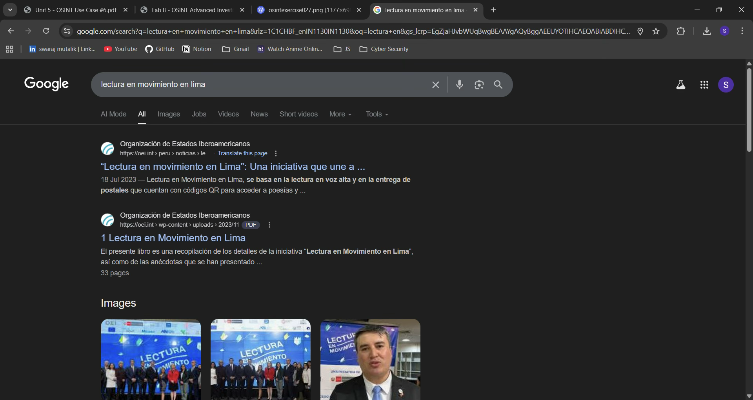
To obtain a starting point i put this image through google lens and also put in a simple google search query as “lectura en movimiento en lima”
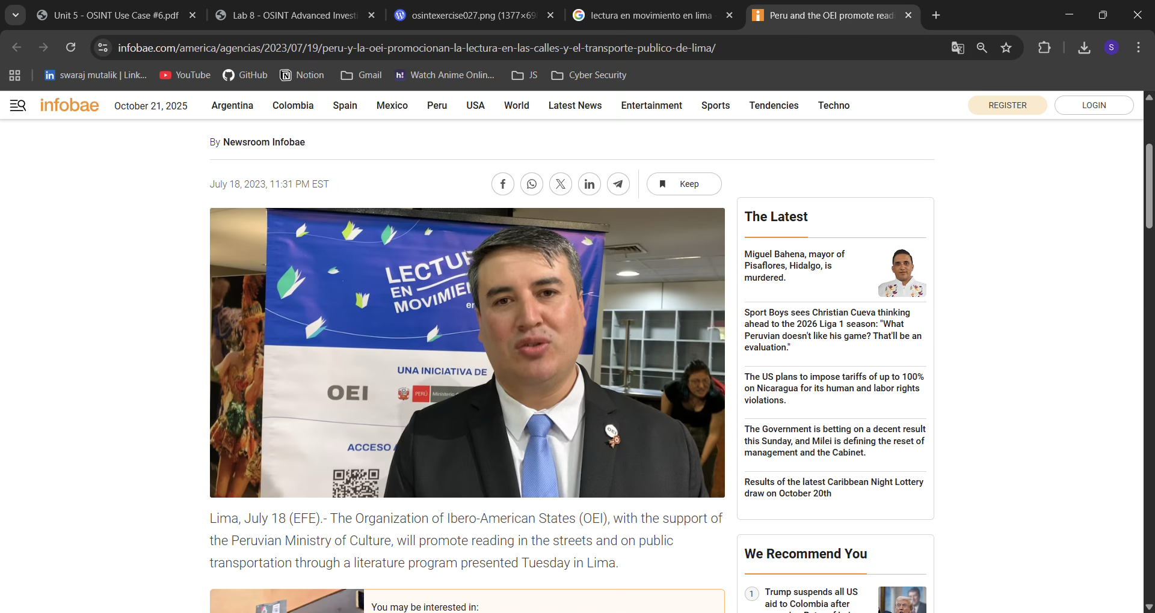

And that’s how i found the name of the speaker – Juan Carlos Ruiz

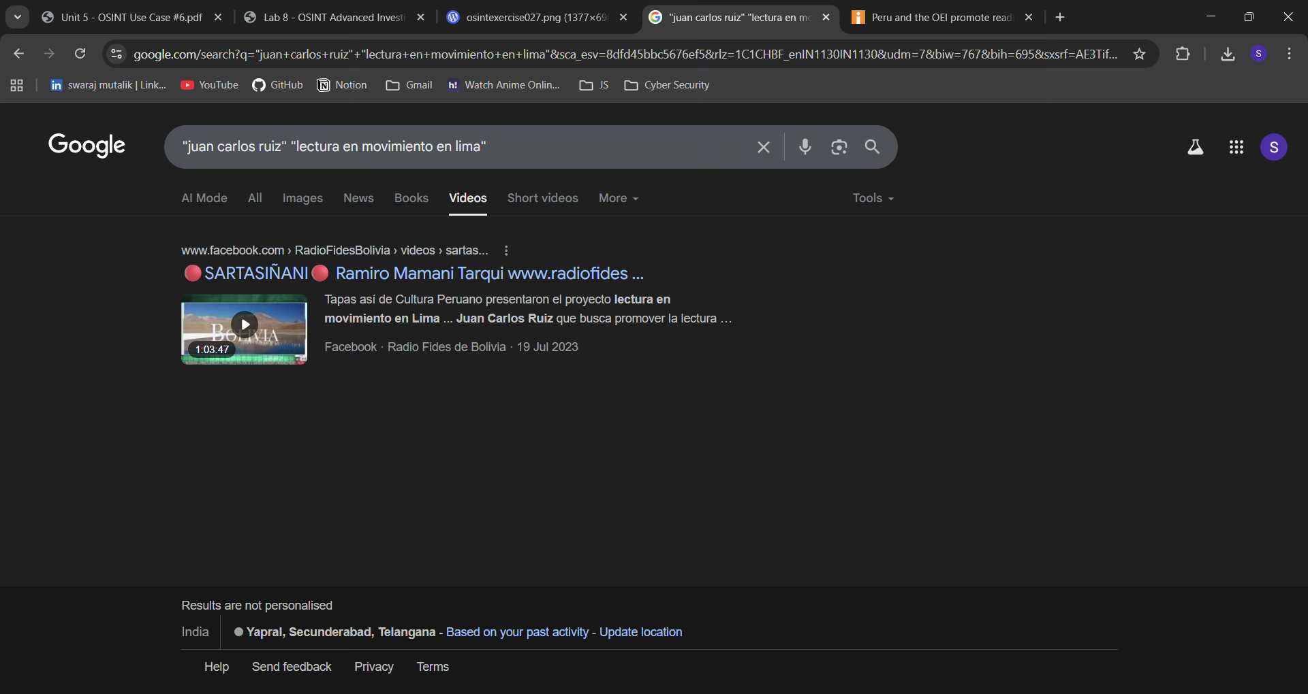
Once I got some information about the speaker in this case the name
I did some advanced google search to look for the specific video of the whole session that was given by Juan Carlos Ruiz.

Investigation 2
For investigating 1 this image has been provided.
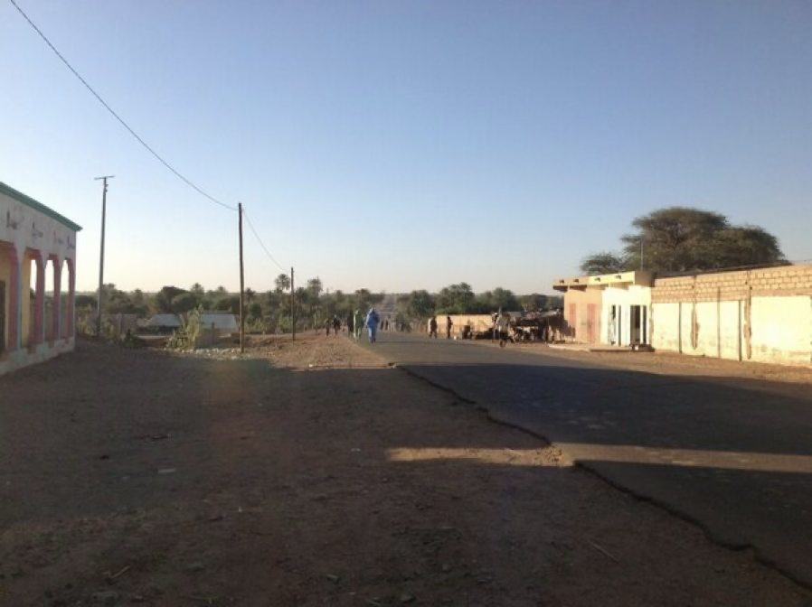
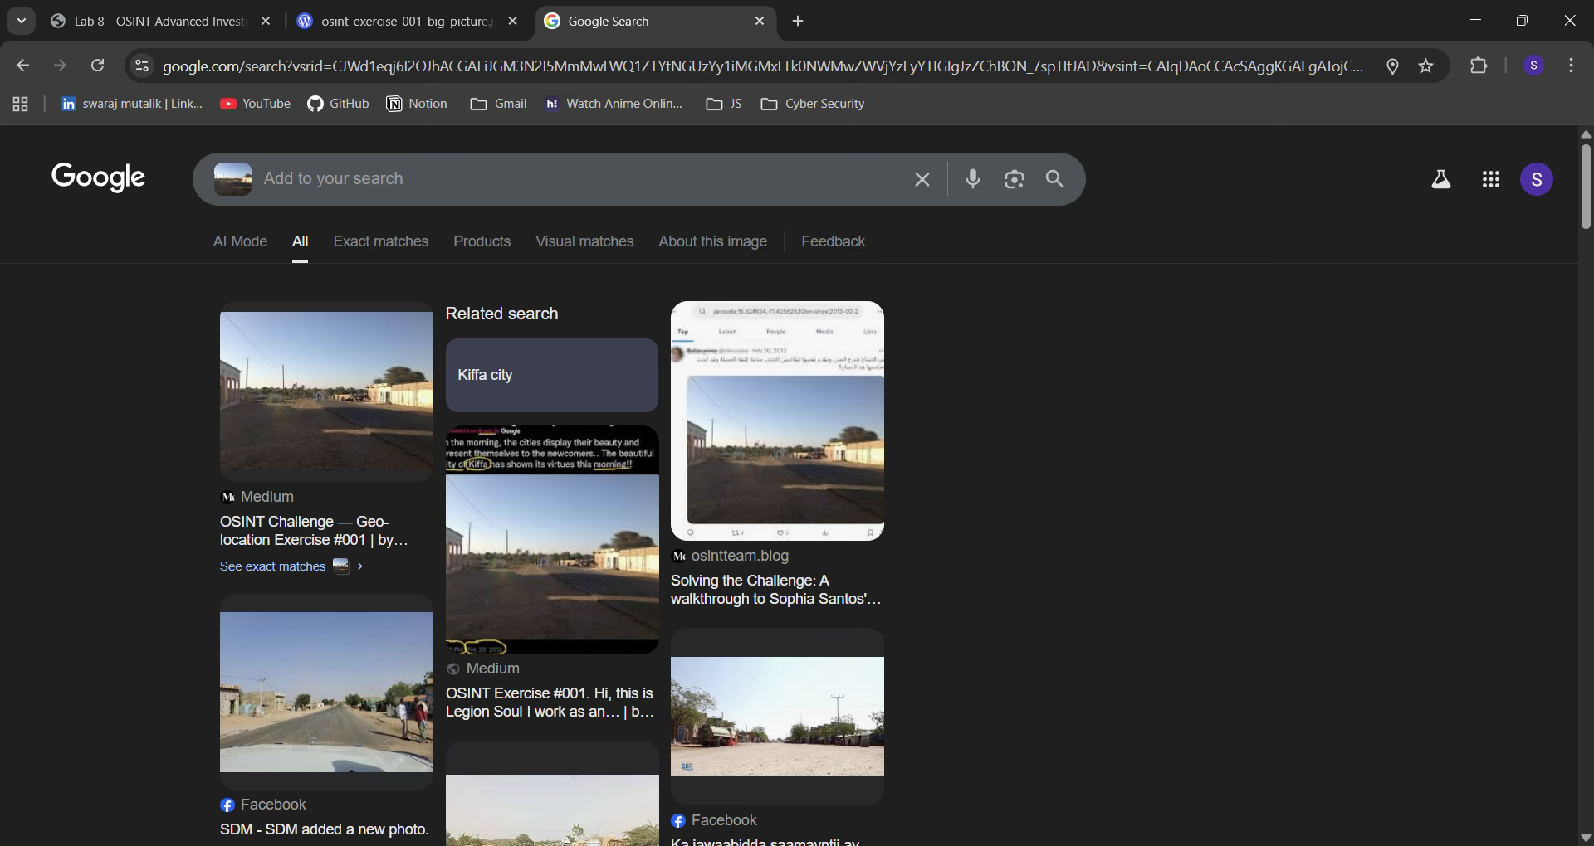
To obtain a starting point for this image investigation i put this image through google lens
City Name – Kiffa
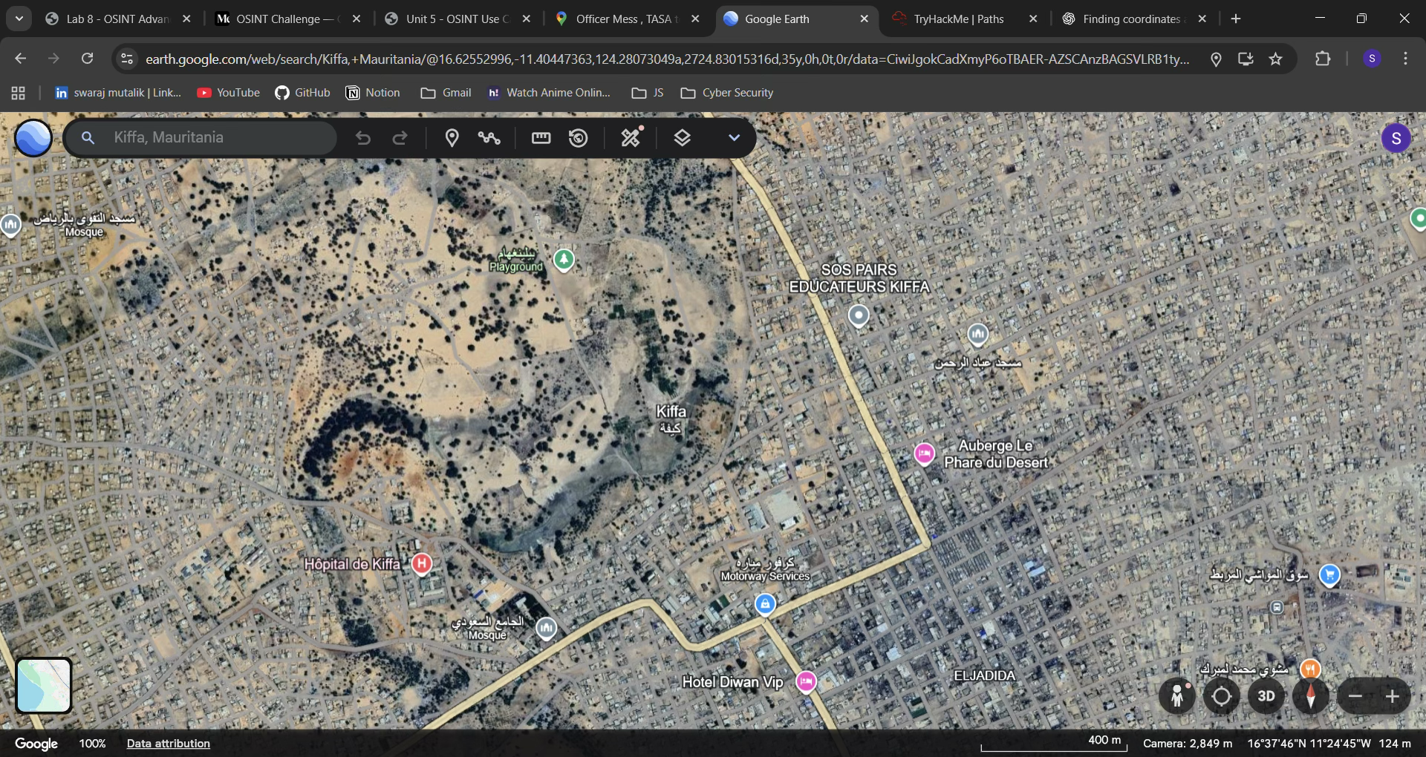
Upon finding the name I ran it through google earth to find out the exact location and coordinates of the image that is to be investigated.
Since most of the roads are dirt roads and not clear roads, it was tough to find the exact location of the image that is to be investigated.
Coordinates of the location - 16°38'02"N 11°24'41"W

Investigation 3
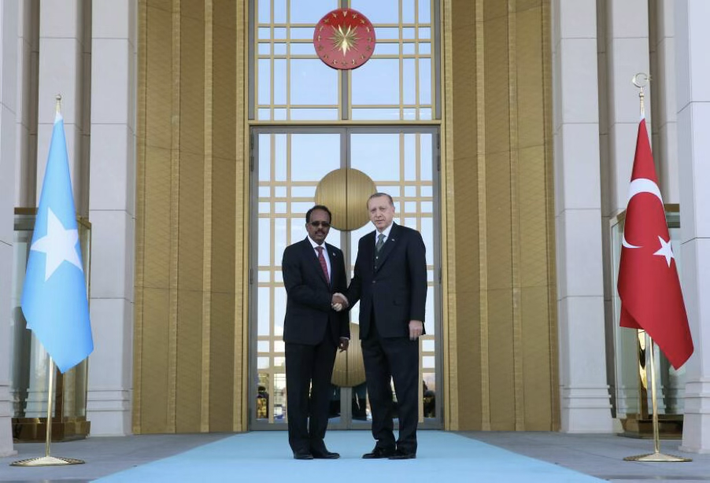
Using a reverse image search engine Yandex, I was able to find the following information.
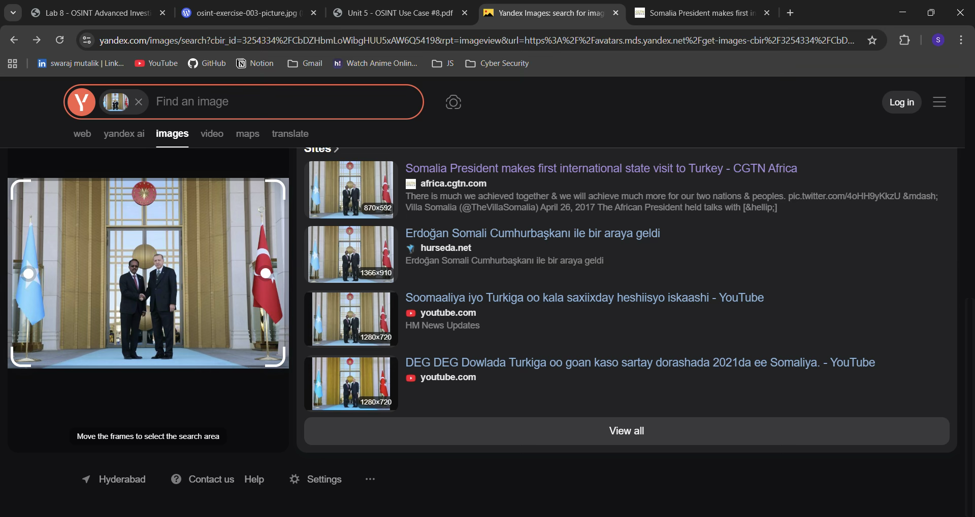
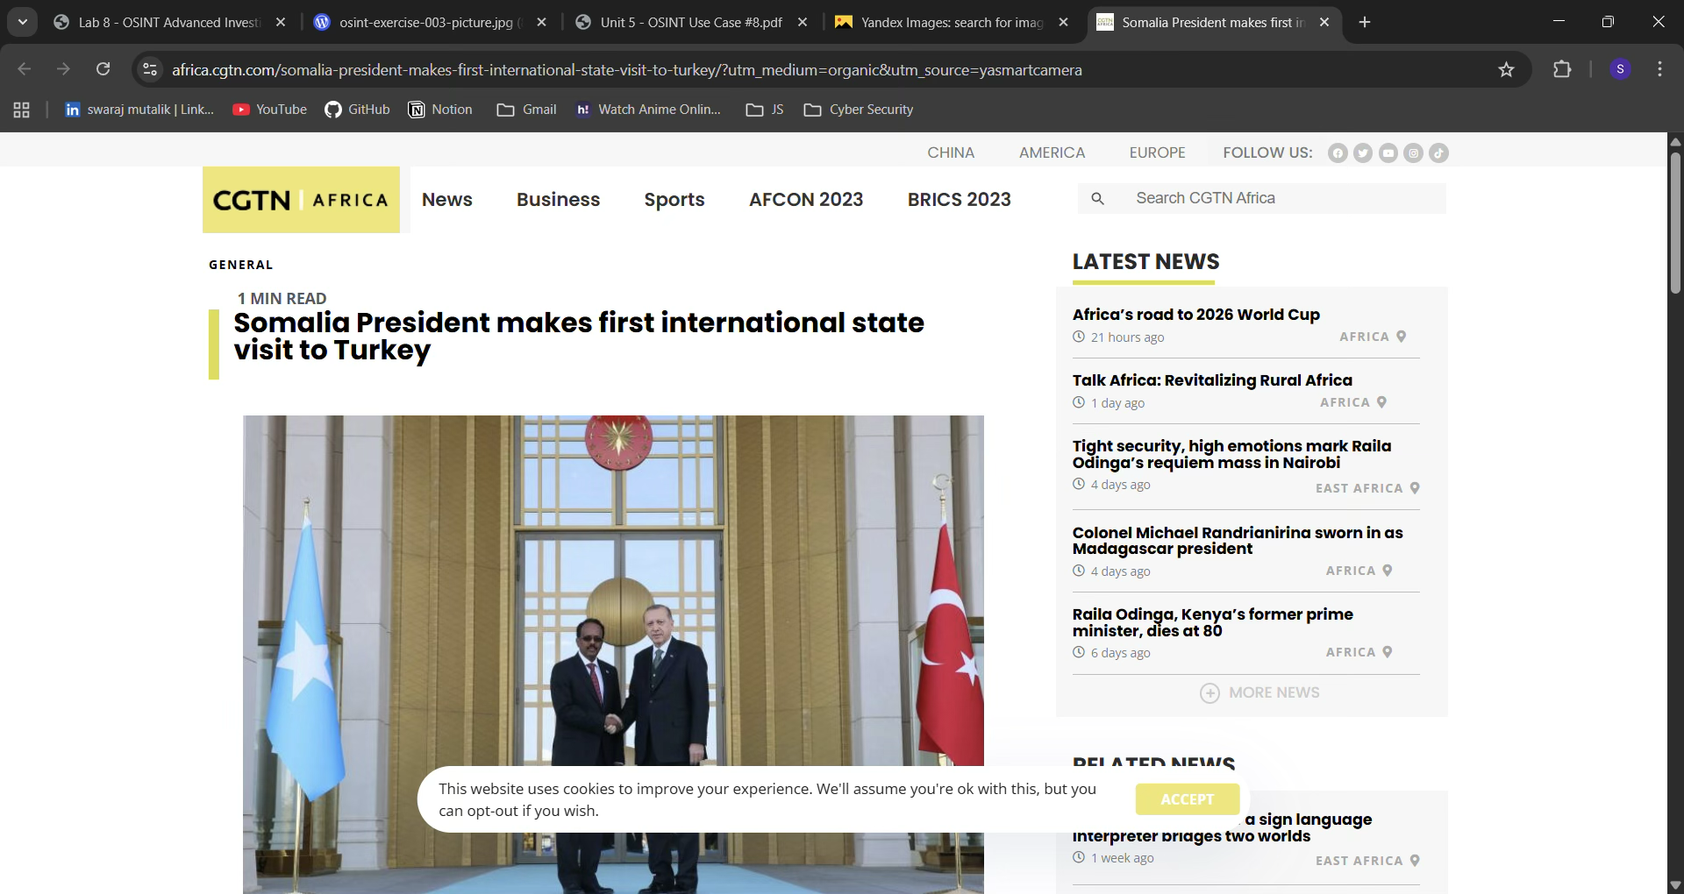
The image was shot at the presidential complex located in Ankara, Turkey.
It is the official residence & administrative HQ of the president of Turkey.
Coordinates of the location - 39°55'51"N 32°47'56"E

Investigation 4 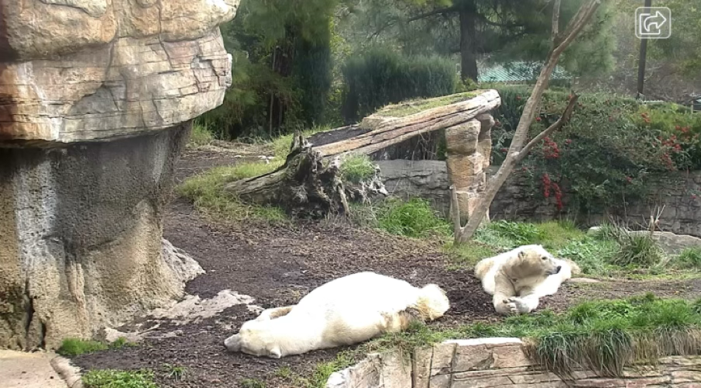
Similarly for this image, I also used Yandex to find some relevant information regarding this image but was not able to find anything useful.
But since the given image seems to be taken in a Zoo, meaning it might had some live cameras nearby. So, I did a google search related to Polar Bears Live Cam.
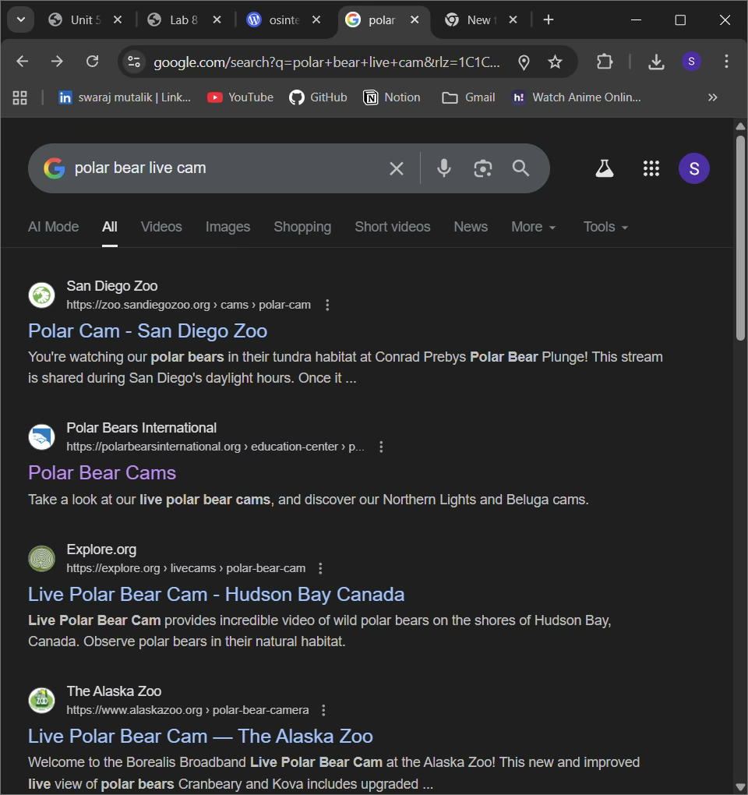
Now we will check all of these links hoping to find something useful.
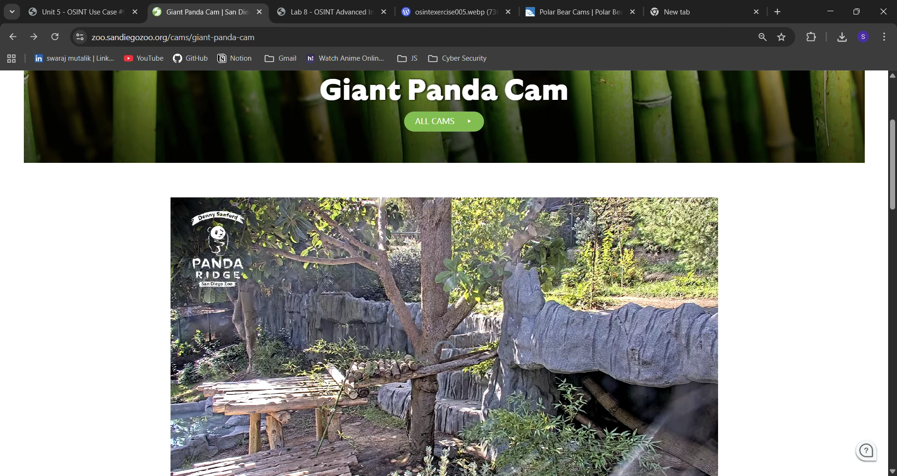
Finally I was able to find that this image was indeed taken from a live camera from a zoo called San Diego Zoo, California, USA.
The coordinates of the Polar Bear San Diego Zoo are -
32.73445890983972 / 32°44'04"N , -117.15453576841819 / 117°09'16"W..
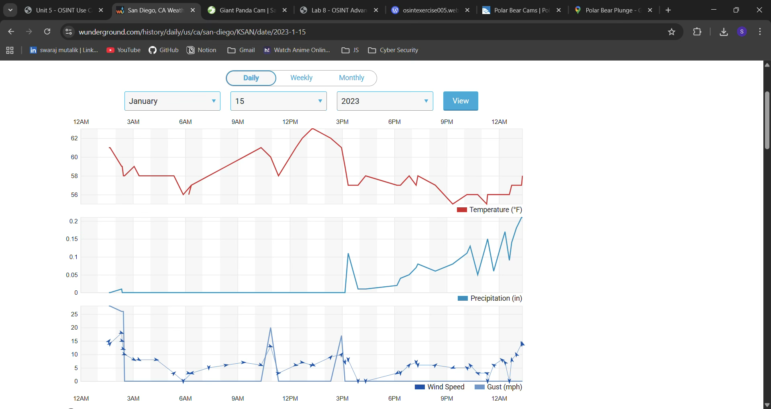
The temperature captured was 62F as the image was taken around 2 PM.
Investigation 5

Similarly for this image, I also used Yandex to find some relevant information regarding this image and was able to find some useful information.
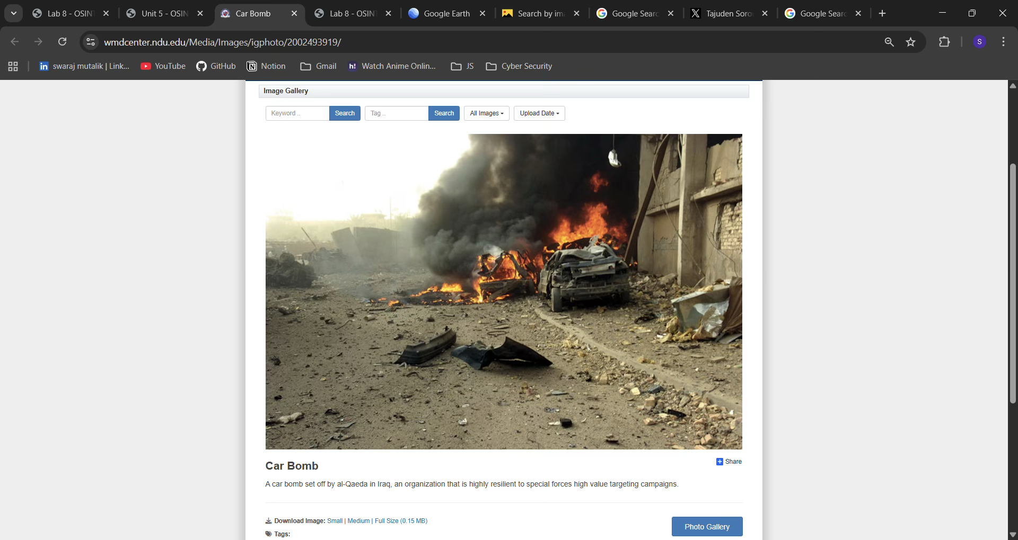
Upon finding out the above information we were able to confirm that this photograph was not from Pakistan, but was taken by al-Qaeda in Iran therefore the person supposedly took this photograph cannot be trusted.
Hence, we can confirm that this tweet is nothing more than misleading information.

---------------------------------END OF DOCUMENT-------------------------------

